FILE Validation and Magic Number Analysis
Submitted By
Name: Abhishek N Shetty
Date: 09/06/2026

File validation
File Validation is a security process used by applications and websites to verify whether an uploaded file is safe, valid, and meets the predefined requirements before it is accepted or processed. File validation plays a critical role in protecting applications from malicious uploads, malware infections, unauthorized file execution, and other security threats.
In modern web applications, users frequently upload files such as images, documents, PDFs, videos, and spreadsheets. Without proper validation mechanisms, attackers may attempt to upload malicious files that can compromise the security, integrity, and availability of the system. Therefore, file validation serves as the first line of defense against potentially harmful file uploads.

File Validation Process
A secure file validation process typically follows multiple verification steps.
User Uploads File
↓
File Extension Validation
↓
File Type Validation
↓
Magic Number Validation
↓
File Size Validation
↓
Content Validation
↓
Malware Scanning
↓
Accept or Reject File
Each step contributes to improving the overall security of the application.

Magic Number
A Magic Number is a unique identifier located at the beginning of a file or data structure. It helps operating systems and applications determine the actual file type regardless of its file extension.
Magic numbers are also known as file signatures.
Common File Magic Numbers
File Type | Magic Number
PDF | %PDF
PNG | 89 50 4E 47
JPEG | FF D8 FF
ZIP | 50 4B 03 04
Example
A PDF file begins with the signature:
%PDF
This signature allows the system to recognize the file as a PDF document even if the file extension has been modified.

10 | Remains constant for the same file format. | Changes depending on the verification process or system requirements.

JWT Storage
What is JWT Storage?
JWT Storage refers to the location where a JSON Web Token (JWT) is stored after a user successfully logs into a website or application.
When a user enters valid login credentials, the server generates a JWT and sends it to the user's browser. The browser must store this token somewhere so that it can be sent with future requests to prove the user's identity.
Without storing the JWT, the user would have to log in again for every request made to the server.

Why is JWT Storage Required?
JWT storage is important because it allows websites and applications to:
- Maintain user sessions.
- Verify user identity.
- Provide access to protected resources.
- Avoid repeated logins.
- Support secure authentication mechanisms.

How JWT Storage Works
The JWT authentication process follows these steps:
User Login
↓
Server Verifies Credentials
↓
JWT Generated
↓
JWT Stored in Browser
↓
JWT Sent with Requests
↓
Server Validates JWT
↓
Access Granted

Which Storage Method is Most Secure?
Among the available storage methods, secure HttpOnly cookies are generally considered the safest option because:
- JavaScript cannot directly access the token.
- Risk of token theft through XSS attacks is reduced.
- Additional security flags can be applied.

JWT Storage Analysis
Target: https://flashyre-dev-496807.appspot.com/login

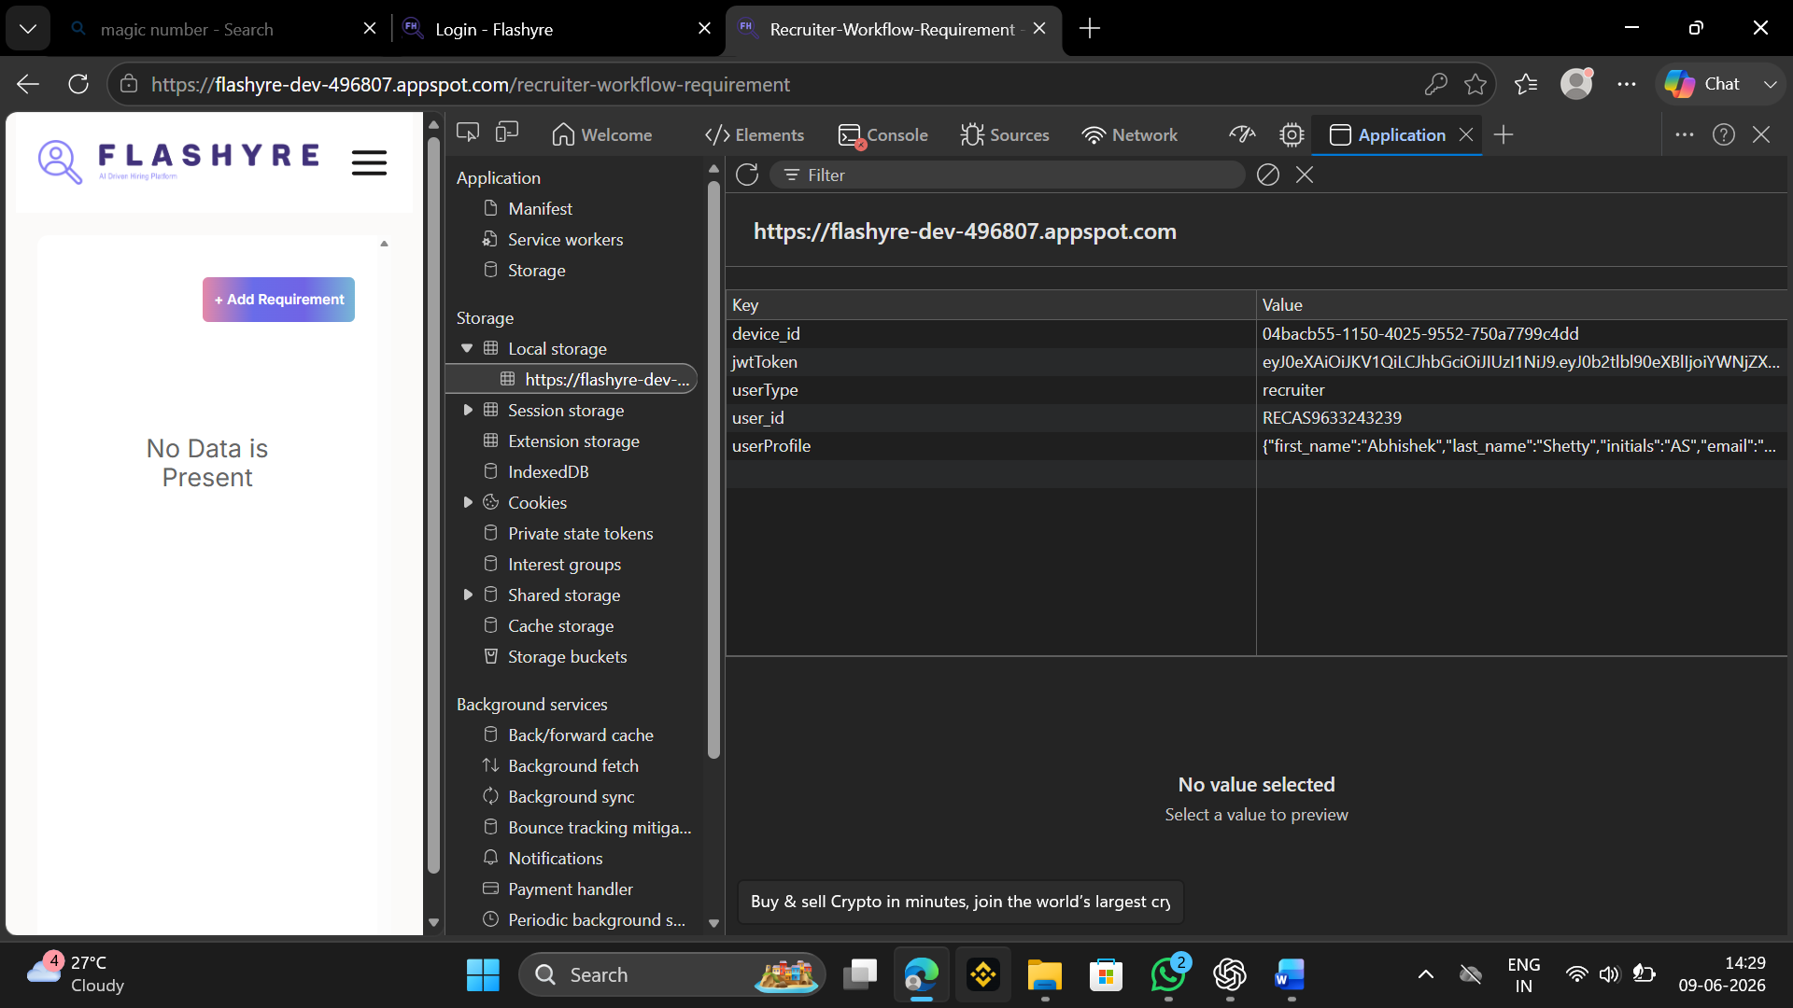

The Application tab of the browser Developer Tools was used to examine the storage mechanisms implemented by the Flashyre web application. During the analysis, the Local Storage section was inspected to identify authentication-related information stored within the browser.

Findings
The analysis of Local Storage revealed multiple stored entries including:
- device_id
- jwtToken
- userType
- user_id
- user Profile

Observation
- JWT token identified in browser Local Storage.
- Authentication token stored under the key jwtToken.
- User profile and session-related information stored locally.
- Local Storage persists data across browser sessions unless manually removed or expired.

